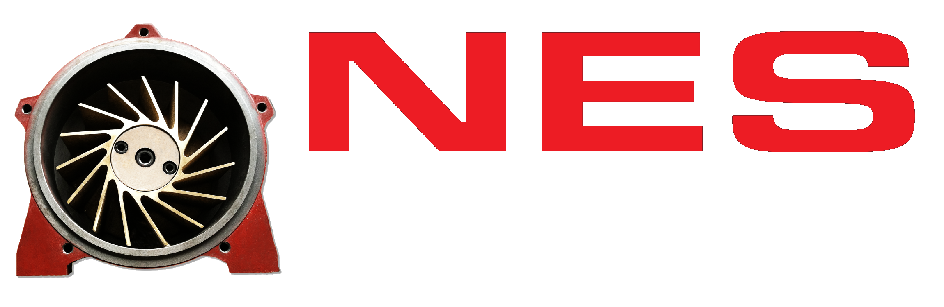 | TECHNICAL BROCHURE · 2026  LIQUID RING VACUUM PUMPS

LIQUID RING VACUUM PUMPS · CONICAL LOBE · SINGLE STAGE
REMANUFACTURED:
CL SERIES
Rebuild it or replace it. Your CL* footprint stays.
REMANUFACTURED CL* · PLUS THE NEW NES NL SERIES DROP-IN REPLACEMENT
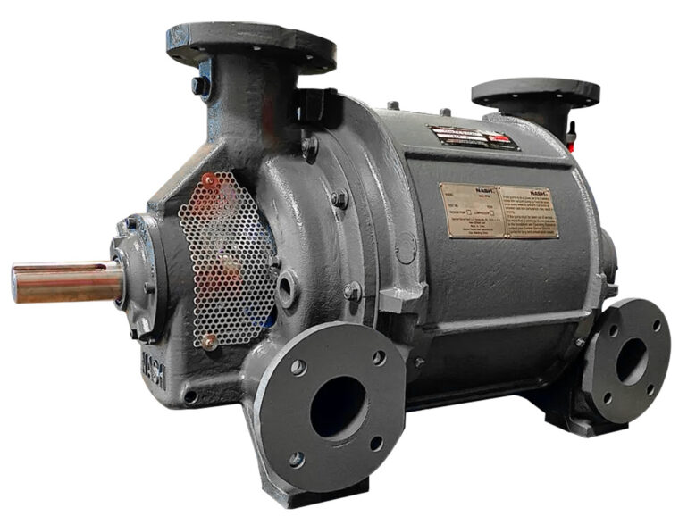

Two NES options for classic Nash* CL* pumps — same footprint, both backed by a 2-year warranty.

— REMANUFACTURED CL  Your OEM pump, rebuilt. Restored to OEM dimensions; 95%+ of new-unit performance guaranteed. | — NL SERIES  A new NES pump. Drop-in aftermarket replacement for classic CL* models, factory performance tested. | — CORE EXCHANGE  Cast iron or stainless. Prepaid return freight on stainless; lead time confirmed at quote. | — STANDARD  No shortcuts. No epoxy or metalizing spray. Made in America.

Same footprint. Two ways forward.
Keep the Nash* CL* you already trust with an NES remanufacture, or install a new NES NL Series pump built to drop into the same space. Either way, your piping and base stay put.
NL CAPACITY  200–10,000  CFM across 25 models |  | MAX VACUUM  27.5" HG  depending on model |  | MOTOR RANGE  10–550 HP  NL Series |  | WARRANTY  2 YR  on both offerings

Two Offerings / One Footprint | CL* SERIES SOLUTIONS  TECHNICAL BROCHURE · 2026

REMANUFACTURED CL* VS. NL SERIES
▬▬▬
 | OPTION A  REMANUFACTURED CL* | OPTION B  NL SERIES
WHAT IT IS | An original Nash* CL* pump remanufactured by NES to OEM specifications. | A new NES-built, single-stage conical lobe (dual cone) pump — a drop-in aftermarket replacement for classic CL* pumps.
MODELS | CL-200* through CL-6000*. | 25 models, NL-402 through NL-9003, each matched to a CL* model.
CONSTRUCTION | Cast iron. Stainless steel (limited availability). | Cast iron with PTFE packing standard. 304 SS, 316 SS-clad and bronze options; FKM (Viton*) mechanical seals optional.
PERFORMANCE | Guaranteed to perform at 95% or more of a new unit. | 200–10,000 CFM, to 27.5" Hg depending on model. Factory performance tested.
WARRANTY | 2 years against manufacturing defects. | 2 years against manufacturer's defects.
AVAILABILITY | Remanufactured to order; lead time confirmed at quote. | Standard models typically ship from stock.
GOOD FIT WHEN | You want to keep your OEM pump in service and can plan around the rebuild lead time. | You need a pump quickly, want a new unit, upgraded materials, or have no core to return.
OPTION A — HOW A REMANUFACTURE WORKS
▬▬▬
— 01 SEND  Your pump or core. Ship your CL* to NES, cast iron or stainless. Stainless exchanges include prepaid return freight. | — 02 INSPECT & QUOTE  Fully documented. Inspection report plus a quote with photos and a bill of materials. | — 03 REBUILD & RETURN  Back to OEM spec. Remanufactured to OEM dimensions, then shipped back for drop-in reinstallation.
OPTION A — INSIDE AN NES CL* REBUILD
▬▬▬
COMPONENT | CAST IRON | STAINLESS STEEL
Body | Stainless shroud rings welded in; compression areas nickel-welded and machined to OEM dimensions | Stainless plate rolled, welded and machined to OEM dimensions
Heads | Bores and stuffing boxes sleeved; worn faces nickel-welded and machined | Bores sleeved; rolled stainless face plate with countersunk stainless screws
Cones | OD machined to remove wear and eccentricity; flanges trued | ¼" stainless skin welded, ported and machined; flanges trued
Shaft & rotor | Journals sleeved; blade tips repaired; tapers nickel-welded; aligned and balanced as needed | Shroud OD stainless rings welded; vane tips and buckets repaired; balanced as needed
Assembly | New bearings, lip seals and check valves to OEM spec; mechanical seals refurbished | Same as cast iron

NL Series / Specifications | CL* SERIES SOLUTIONS  TECHNICAL BROCHURE · 2026

OPTION B — NL SERIES SELECTION TABLE
▬▬▬
NL MODEL | REPLACES | MOTOR HP | CAPACITY (CFM) | MAX VAC. ("Hg) | INLET / OUTLET (in) | SEAL WATER (GPM) | SEAL CONN. (in)
NL-402 | CL-402 | 20–30 | 300–440 | 26 | 3 FL / 2½ FL | 12 | ¾ NPT
NL-403 | CL-403 | 20–40 | 200–440 | 27.5 | 3 / 2½ FL | 12–15 | ¾ NPT
NL-701 | CL-701 | 10–50 | 500–800 | 19 | 4 FL / 3 FL | 10 | 1 NPT
NL-702 | CL-702 | 30–50 | 500–750 | 25 | 4 FL / 3 FL | 20 | 1 NPT
NL-703 | CL-703 | 25–50 | 400–750 | 27 | 4 FL / 3 FL | 16–20 | 1 NPT
NL-1001 | CL-1001 | 20–75 | 800–1,150 | 20 | 5 FL / 4 FL | 10–20 | 1 NPT
NL-1002 | CL-1002 | 40–75 | 850–1,150 | 25 | 5 FL / 4 FL | 20–30 | 1 NPT
NL-1003 | CL-1003 | 40–75 | 700–1,050 | 27 | 5 FL / 4 FL | 20–30 | 1 NPT
NL-1501 | CL-1501 | 20–100 | 1,000–1,700 | 20 | 6 FL / 4 FL | 20–30 | 1 NPT
NL-1502 | CL-1502 | 40–100 | 500–1,650 | 27.5 | 6 FL / 4 FL | 25–30 | 1 NPT
NL-2001 | CL-2001 | 30–150 | 1,500–2,200 | 19 | 6 FL / 5 FL | 10–20 | 1 NPT
NL-2002 | CL-2002 | 50–125 | 1,300–2,200 | 24.5 | 6 FL / 5 FL | 20–40 | 1 NPT
NL-2003 | CL-2003 | 60–150 | 1,150–2,200 | 27 | 6 FL / 5 FL | 30–60 | 1 NPT
NL-3001 | CL-3001 | 50–200 | 2,400–3,200 | 19.75 | 8 FL / 6 FL | 10–30 | 1 NPT
NL-3002 | CL-3002 | 100–200 | 2,100–3,200 | 24.5 | 8 FL / 6 FL | 40–70 | 1 NPT
NL-3003 | CL-3003 | 100–200 | 1,000–3,000 | 27.5 | 8 FL / 6 FL | 25–70 | 1 NPT
NL-4001 | CL-4001 | 60–250 | 3,000–4,800 | 17.5 | 10 FL / 8 FL | 10–40 | 1½ NPT
NL-4002 | CL-4002 | 125–250 | 2,800–4,600 | 24 | 10 FL / 8 FL | 50–60 | 1½ NPT
NL-4003 | CL-4003 | 125–250 | 2,100–4,500 | 27 | 10 FL / 8 FL | 30–100 | 1½ NPT
NL-6001 | CL-6001 | 100–350 | 4,800–7,000 | 18 | 12 FL / 10 FL | 40–55 | 1½ NPT
NL-6002 | CL-6002 | 200–350 | 4,500–7,000 | 22.5 | 12 FL / 10 FL | 60–120 | 1½ NPT
NL-6003 | CL-6003 | 200–400 | 3,000–6,800 | 26.5 | 12 FL / 10 FL | 30–100 | 1½ NPT
NL-9001 | CL-9001 | 150–500 | 7,000–10,000 | 13–18 | 14 FL / 12 FL | 60 | 2 NPT
NL-9002 | CL-9002 | 300–500 | 7,200–9,800 | 20–23 | 14 FL / 12 FL | 120 | 2 NPT
NL-9003 | CL-9003 | 350–550 | 6,600–9,200 | 27 | 14 FL / 12 FL | 200 | 1½ NPT
Note: Values as published by NES for the NL Series. Ranges vary with model, speed, motor and seal water conditions — select from the model's performance curve. FL = flanged. Rows are shaded by frame size. Data applies to NL Series pumps only; remanufactured CL* pumps are restored to 95%+ of the original OEM performance for that model.

FULL TECHNICAL DATA
Contact NES for NL performance curves, casting and manifold drawings, the O&M manual, or a quote on remanufacturing or exchanging your CL*.

Applications / Notices | CL* SERIES SOLUTIONS  TECHNICAL BROCHURE · 2026

NL SERIES APPLICATIONS
▬▬▬
▸ Autoclaves | ▸ Chucking | ▸ Container filling | ▸ Labeling & forming
▸ Cooking | ▸ Decorating | ▸ Deodorizing | ▸ Evaporating
▸ Eviscerating | ▸ Exhausting | ▸ Extruder venting | ▸ Engineered systems

SERVICE & SUPPORT
▬▬▬
▸ Inspection & PM — fiberscope inspections and preventive maintenance schedules.
▸ Parts & repair kits — readily available for NL Series and CL* pumps.
▸ Proven repairs — NES rebuilds of a CL* 9003* and a 904* have run for 28 years.

IMPORTANT NOTICES
▬▬▬
Trademarks. NES Company is an independent manufacturer, remanufacturer and distributor of OEM and non-OEM vacuum pumps. It is not affiliated with, endorsed by or sponsored by Nash, Gardner Denver, Ingersoll Rand or any other company named in this brochure. Nash, CL, Viton and all model designations (marked *) are the property of their respective owners and are used for identification and comparison only.
NL Series. NL Series pumps are designed and supplied by NES and are not Nash* products. References to CL* models indicate intended dimensional and functional interchangeability only; confirm fit against your installation before ordering.
Performance data. Published values are typical ranges for preliminary selection, not a performance guarantee unless certified by NES in writing for a specific order. Actual performance depends on speed, motor, seal water temperature and flow, altitude, gas composition and condition of the system.
Warranty & exchange. Remanufactured CL* pumps are guaranteed to perform at 95% or more of new-unit performance. Both offerings are warranted for two years against manufacturing defects. Core return requirements, exchange credits and complete warranty terms are set by the NES quotation and NES Terms & Conditions, which govern.
Installation & changes. Do not use this brochure for installation or piping design; request certified drawings for your order. Specifications are subject to change without notice. Remanufactured CL* pumps are made to order; NL Series stock and all lead times are confirmed at the time of inquiry.

  SCAN FOR  NESCOMPANY.COM | NES COMPANY  333 Route 46 West, Building B, Suite 180  Fairfield, NJ 07004  nescompany.com · info@nescompany.com · 1-800-297-3550  © 2026 NES Company. All rights reserved. Made in America.

